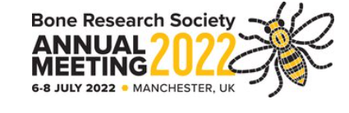

CONFIRMATION OF ELIGIBILITY

NEW INVESTIGATOR AWARD AND/OR CONCESSION RATE REGISTRATION

Name: Click or tap here to enter text.

Abstract: Click or tap here to enter text.

Please select which of these you are applying for:
☐New Investigator Award
☐Reduced Rate Registration

New Investigator Award 2022
Eligibility criteria: (you must meet all criteria 1 to 4)
- A Member of BRS (at the time of applying and during the annual meeting)
- In training or within 5 years of attainment of higher degree or completion of specialist training based on full time equivalent work (allowances can be made for career breaks e.g. maternity leave/sickness/changing careers or for those working part time; please add details).
- You will be the presenting author of the abstract
- You will only be eligible for an award if you have not been awarded one in the previous two years.

Concession/Reduced Rate Registration 2022
Eligibility criteria: (you must meet criteria 1 and then one or more of 2, 3, 4 & 5)
- A Member of BRS (at the time of applying and during the annual meeting)
- In training or within 5 years of attainment of higher degree or completion of specialist training based on full time equivalent work (allowances can be made for career breaks e.g. maternity leave/sickness/changing careers or for those working part time; please add details).
- Or you must be earning less than £20K per annum
- Or from a current lower-middle-income country
- Or Retired.

The above applicant has applied for an award and/or the concession rate when registering and/or submitting his/her abstract for the above meeting. Please fill in your details below to verify their eligibility.
I confirm that the applicant meets the above criteria:

Head of Department Name: Click or tap here to enter text.

Head of Department Email: Click or tap here to enter text.

Signature:

Date:

Please return this form when completed within seven days of registering to events@boneresearchsociety.org

