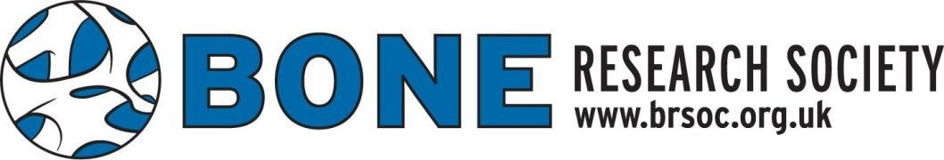

BRS POLICY FOR THE SPONSORSHIP/ENDORSEMENT OF LOCAL OR SPECIALIST GROUPS MEETINGS

AIM: A transparent fair process for supporting local researchers holding meetings

INTRODUCTION
The BRS is here to promote and foster the bone community so that the UK remains at the forefront of musculo-skeletal research and healthcare innovation. The BRS aims to bring together basic and clinical researchers so that we can provide a forum for collaboration and advancement of musculo-skeletal science and health. The aim of the BRS specialist meetings are to help realise these aims. To facilitate the BRS supporting meetings, please complete the attached form.
METHOD:
- Applicant(s) complete application form (see Appendix)
- Applications reviewed by BRS officers within 4 weeks for preliminary funding decision with potential questions
- Final funding decision pending satisfactory response to questions
- Funding given
- Receipts and feedback from workshop submitted.
ELIGIBILITY & TERMS OF AWARD
- The applicant must have been a member of BRS for at least 6 months prior to application.
- Successful applications will be required to submit a report to the BRS within 3 months of the meeting. This should include the purpose of the workshop and the benefits to the BRS.
- BRS will award up to £500 to support local meetings: normally a maximum of 3 awards each per calendar year.
- Money will be paid once receipts have been received by the BRS treasurer.
- BRS will only support local meetings to be held within the UK.
- The support of BRS should be clearly acknowledged at the meeting.
- Applications must be submitted at least 8 weeks in advance of the proposed meeting. Only applications submitted on the official application form will be considered.
APPENDIX
BRS sponsorship/ endorsement of specialist meetings Application form.

