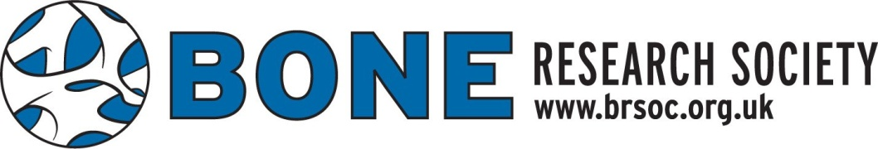
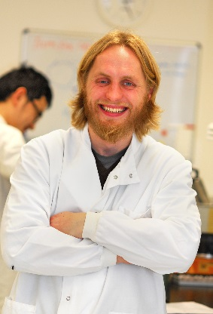

The Bone Research Society Neil Mackenzie Public Engagement Award
This prize is awarded annually in memory of Neil Mackenzie who tragically lost his life in a climbing accident in Canada in January 2015. It provides a bursary to support members participating in, or developing activities related to, public engagement. The overall aim is to enhance awareness of the basic, clinical and/or translational research that is undertaken by members of the Bone Research Society (BRS).
Neil was an enthusiastic contributor to the life of the BRS and an excellent, promising young scientist. His infectious enthusiasm for research led him to serve in the past as a New Investigator representative on the BRS Committee and as such, this award honours his vigour and commitment to both the society and the bone field.
Members, and in particular New Investigators, are invited to submit an application for the 2021 Neil Mackenzie Public Engagement Award. Normally, these public engagement events are run in association with the annual meeting, however, due to the ongoing Covid-19 pandemic the timing of any such sessions in 2021 is flexible.
To apply, please email info@boneresearchsociety.org with details of the public engagement session you would like to run. The application (no more than 500 words) should include a title, aims and objectives and a summary of the scientific content. Please also include a brief description of how the session will be run (e.g. online) and when you would intend for it to take place.
The successful applicant/s will also be awarded a total of £500 which can be used, for example, for the purchase of materials for the presentation.

