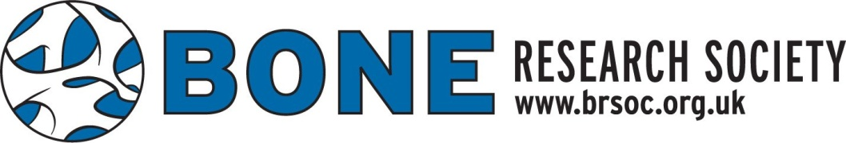
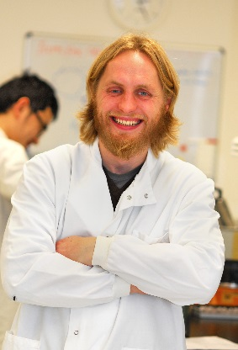

The Bone Research Society Neil Mackenzie Public Engagement Award 2020
The BRS would like to announce the launch of the Neil Mackenzie Public Engagement Award 2020. For this year, New Investigators are invited to submit a 150-word summary of a public engagement talk to be presented at the Manchester SciBar event at the Pen and Pencil pub in Manchester on Thursday 25th June at 6:30pm. SciBar is simply science in a bar - every month a different scientist leads a 30-minute discussion about their research for a public audience. Following the talk, there is an opportunity for the audience to ask questions and discuss the speaker’s research. The winner will present their talk in Manchester shortly before the 2020 BRS Meeting to be held in the city (http://boneresearchsociety.org/meeting/manchester2020/).
To apply, please email a talk title and summary of the talk (maximum 150 words) to info@boneresearchsociety.org by Friday 21st February 2020. The talk title and summary should be engaging and written for a non-scientific audience, see previous examples at https://www2.mmu.ac.uk/engage/what-we-do/scibar/. The successful applicant must be available to present the talk in Manchester on Thursday 25th June; as part of the award their travel to Manchester and one night’s accommodation will be supported.
Eligibility:
- A member of BRS at the time of applying
- A PhD student or within 5 years of attainment of higher degree or completion of specialist training

